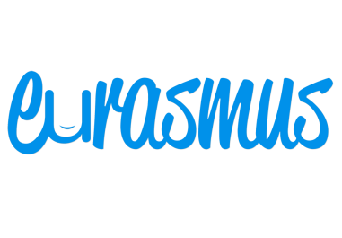**The Ambassador Programme by**

The ambassador position is a volunteer position that allows the students the opportunity to showcase their ability and work on the [Eurasmus.com](http://www.eurasmus.com/en) website, that in the future will be seen by thousands of people each day.

Moving to another city or country is not required in order to become part of the programme. The tasks assigned to the ambassador are not stressful, have relaxed deadlines and give the opportunity to build employability skills.

The position is divided into two different parts.

The first part includes generating content for the website of [Eurasmus.com](http://www.eurasmus.com/en), under the form of articles, blogs, city guides, info pages, etc. The writings can be related to different topics and subjects, depending on what information the students need and what is interesting for them. A sufficient knowledge in English is required. However, the position gives the opportunity to constantly improve this skill with the assigned tasks.

The second part of the ambassador programme in more interactional. A group of students, who have applied for an internship or accommodation through the Eurasmus website, will be assigned to the ambassador. In case they need more information, have questions, face some problems or need help in general, the ambassador will be their contact person in the particular city. For Eurasmus.com it is important to increase the student mobility through Europe and make the student life abroad easier!

The deadline for the weekly updates and the deadline for the different tasks will be every Thursday at 6pm Spanish time. The ambassador will be required to send an update on what they have accomplished during the week. It may not always include a finished work because some of the assignments have a deadline of 2-3 weeks. However, for Eurasmus.com is important to keep in touch with its ambassadors, follow their progress and guide their learning process.

�What are the benefits for the ambassador?

The ambassador will be asked to collect all their work for Eurasmus.com in a portfolio under the form of links that will be sent back every week by the supervisor. This portfolio can be shown to future employers and can create advantage for the ambassador over the other candidates.

Receiving constructive feedback is a really important part of every learning process. Therefore, monthly seminars though Skype will be organised in order to improve the work and discuss different issues the ambassador might have.

The programme also offers the unique opportunity to improve employability skills whilst studying or working, and also the possibility to add another reference to the ambassador’s CV.